J.P.BADRI(192524301)
Set 5: Website Analytics
Dataset: Website Traffic
Date Page Views Click-through Rate
- Create a line chart to visualize the trend in daily page views over time. Label the axes and title the chart.
- Generate a bar chart showing the top N days with the highest click-through rates. Label the chart elements.
- Develop a stacked area chart to display the distribution of user interactions (likes, shares, comments) on a website.
- Build a Tableau dashboard with the line chart and bar chart for interactive exploration of website traffic data.
SOLUTION :

CODE :
import pandas as pd import matplotlib.pyplot as plt import plotly.express as px import plotly.graph_objects as gg from plotly.subplots import make_subplots

df_traffic = pd.DataFrame({
'Date': ['2023-01-01', '2023-01-02', '2023-01-03', '2023-01-04', '2023-01-05'],
'Page_Views': [1500, 1600, 1400, 1650, 1800],
'CTR': [2.3, 2.7, 2.0, 2.4, 2.6]
})

df_interactions = pd.DataFrame({
'Date': ['2023-01-01', '2023-01-02', '2023-01-03', '2023-01-04', '2023-01-05'],
'Likes': [120, 150, 100, 140, 180],
'Shares': [40, 55, 30, 45, 60],
'Comments': [15, 25, 10, 20, 30]
})

plt.figure(figsize=(8, 4)) plt.plot(df_traffic['Date'], df_traffic['Page_Views'], marker='o', color='purple', linewidth=2) plt.title('Daily Page Views Trend', fontsize=14) plt.xlabel('Date', fontsize=12) plt.ylabel('Page Views', fontsize=12) plt.xticks(rotation=15) plt.grid(True, linestyle='--', alpha=0.6) plt.tight_layout() plt.show()

N = 3 top_ctr = df_traffic.sort_values(by='CTR', ascending=False).head(N)

plt.figure(figsize=(8, 4)) plt.bar(top_ctr['Date'], top_ctr['CTR'], color='darkorange', edgecolor='black') plt.title(f'Top {N} Days with Highest Click-Through Rates (CTR)', fontsize=14) plt.xlabel('Date', fontsize=12) plt.ylabel('Click-Through Rate (%)', fontsize=12) for i, val in enumerate(top_ctr['CTR']):
plt.text(i, val + 0.05, f"{val}%", ha='center', fontweight='bold') plt.tight_layout()
plt.show()

plt.figure(figsize=(8, 4)) plt.stackplot( df_interactions['Date'], df_interactions['Likes'], df_interactions['Shares'], df_interactions['Comments'], labels=['Likes', 'Shares', 'Comments'], colors=['#6baed6', '#74c476', '#fdae6b'], alpha=0.85
)
plt.title('Distribution of User Interactions Over Time', fontsize=14) plt.xlabel('Date', fontsize=12) plt.ylabel('Interaction Count', fontsize=12) plt.legend(loc='upper left') plt.xticks(rotation=15) plt.tight_layout() plt.show()

fig = make_subplots( rows=1, cols=2, subplot_titles=("Daily Page Views", "Top CTR Days")
)

fig.add_trace(gg.Scatter(x=df_traffic['Date'], y=df_traffic['Page_Views'], mode='lines+markers', name='Page Views'), row=1, col=1)
fig.add_trace(gg.Bar(x=top_ctr['Date'], y=top_ctr['CTR'], marker_color='orange', name='CTR (%)'), row=1, col=2)

fig.update_layout(title_text="Set 5: Website Analytics Interactive Dashboard", height=450) fig.show()
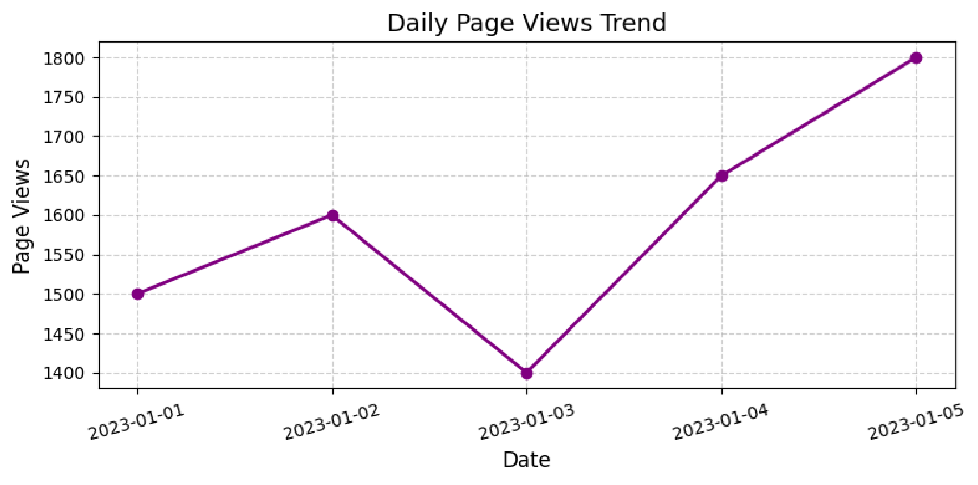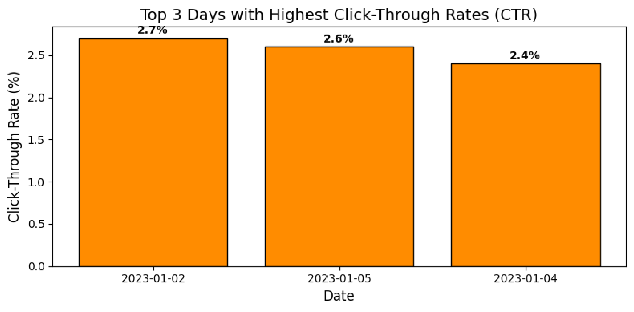
OUTPUT :

